1.Plot three curves for accuracy for year 1

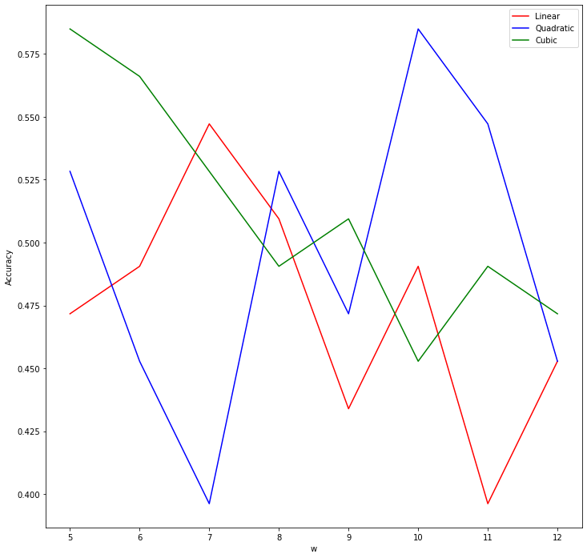

2.For each d take the best W

Linear is 7, Quadratic is 10, Cubic is 5

Linear = 0.51

Quadratic = 0.53

Cubic = 0.53

3. Confusion Matric

4.Trading strategy

Linear = 93

Quadratic = 116

Cubic = 106

BH = 121

In my opinion, linear regression is not a good model for predicting future stock’s price